IBANDA DISTRICT INVESTMENT PLAN

INTRODUCTION.
Ibanda District is located in South Western Uganda. It borders with the Districts of Mbarara in the south, Kiruhura in the East, Buhweju in the West and Kamwenge in the North. The District was curved from Mbarara District and started its operations on 1st July 2005. It is composed of only one county of Ibanda. The District has three constituencies of Ibanda North, Ibanda South and Ibanda Municipality which was created recently with the beginning of the Financial Year 2017/2018. It has got one Municipality (1), four (4) Town Councils, 8 sub counties, 58 Parishes, 590 cells/villages with atotal population of 156,917. The District Arable land area is 2300km. the District has mixed tribes speaking different languages including Runyankore, Rukiga, Rutoro, Rutagwenda, Rufumbira and others. The main economic activity is agriculture with coffee, bananas, dairy, beans and Maize being the major enterprises. Major tradeable include Bananas, coffee, maize, beans, millet, cassava, and all dairy products.
The District Vision is:
“An empowered and Modernized Society by 2040.”
And the Mission is:
“To serve the community through coordinated delivery of services which focuses on national and local priorities in order to promote sustainable social and economic development of the District’’.

MAIN ECONOMIC ACTIVITIES
Agriculture is the main economic activity and source of livelihood in the District, Coffee farming dominates followed by Dairy/livestock, bananas, maize, beans, cassava, sweet potatoes,Irish potatoes, fruits and vegetables grown on small scale mainly for subsistence. Ibanda District has a strong base for agro-processing especially for coffee and all grains- maize, millet, sorghum and ground nuts.
Some of the main economic activities in Ibanda District.major economic activities
Put a chart and percentage per sector.

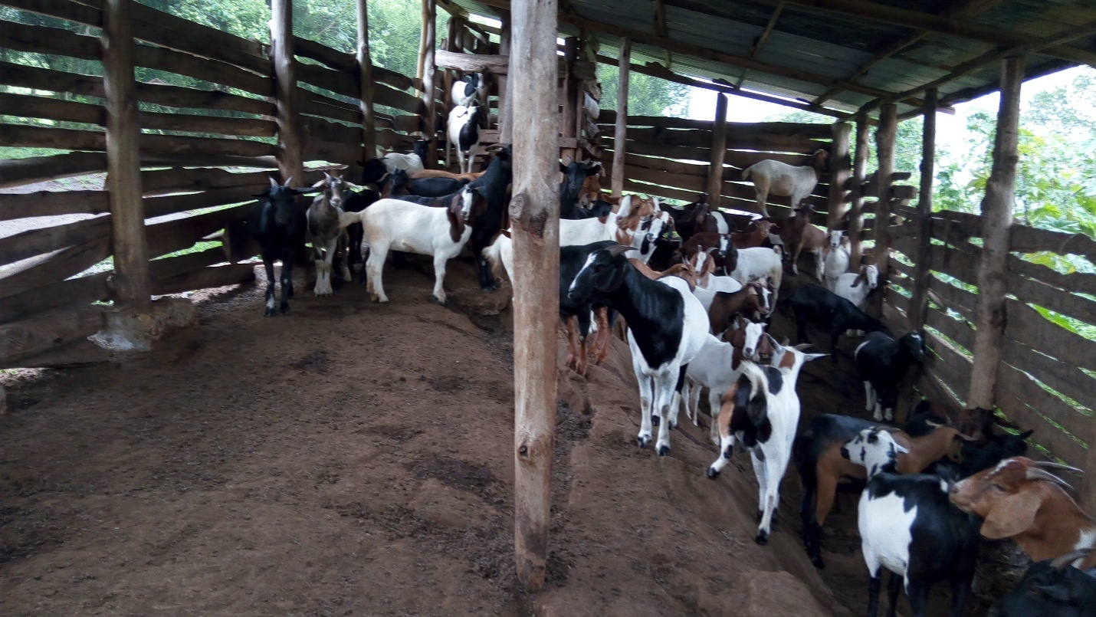

Goat Rearing Project as an economic Activity in Rukiri Sub-County by the Youth Farmers Group. It is also carried out in different parts across the District.
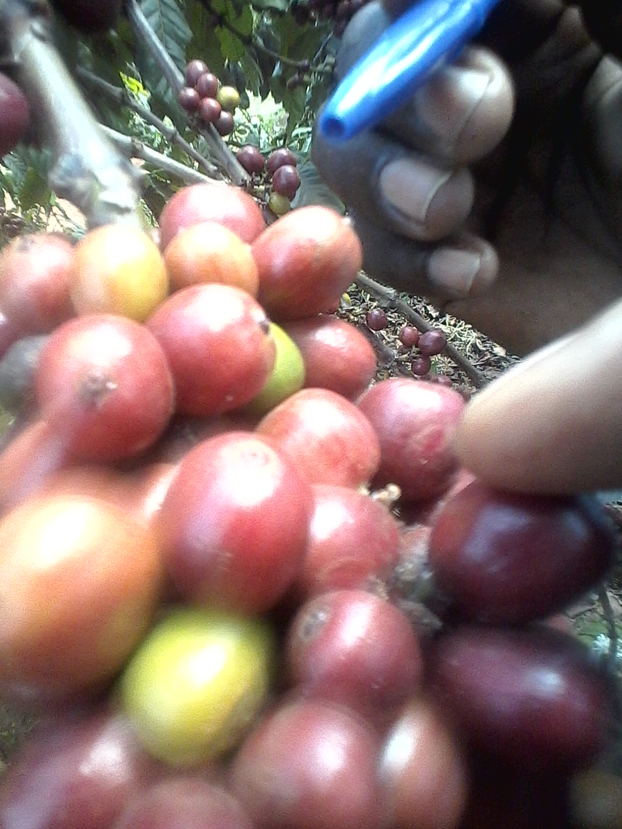
Coffee farming is carried out across the District especially Rukiri and Kicuzi sub counties andit’s one of the lead enterprises being traded in the District.

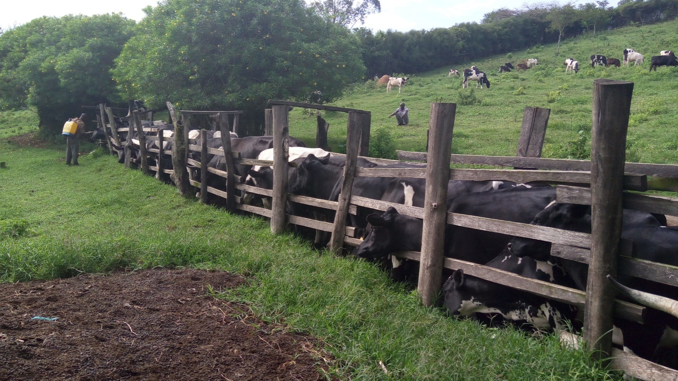
Dairy farming is dominant in most parts of the Municipality and Bull fattening respectively. This has proved to be a serious economic activity and has helped to uplift house hold incomes greatly in the District.

Rural Trading centers with potential to grow into commercial centers have continued to emerge which is attributed to increased rural road network. Similarly, the extension of electricity in rural areas has increased small scale informal sectors activities like metal and furniture fabrication, vehicle repair and maintenance, and other related occupational activities

WHY INVEST IN IBANDA DISTRICT
Existing infrastructure.
Road Network
The District is rich in road network for investors including tarmac and community access roads and there is ongoing rehabilitation and maintenance/construction for allexisting and new roads. Improved transport infrastructure is expected to facilitate access to markets, transportation of raw materials, Grain Trade within and to the neighboring countries such as DRC, Rwanda, Kenya, and other countries

Kamwenge, Ibanda –Mbarara Highway 58 km away from Ibanda Town as you proceed to Kamwenge. The Tarmac Road transports all merchandise, Livestock, grain and therefore facilitating trade and investment in different ways.

The Same highway leads to Kazo-Kiruhura from Ibanda Town and also proceeds to Lyantonde and finally Kampala City.

Water and Electricity-The District has fulltime reliable piped water and electricity existing in major trading centers. This can facilitate investment in manufacturing, agro-processing, Micro Small and Medium Enterprises such as furniture and metal fabrication, electronics, and machinery repairs and maintenance and other informal sector activities. There is also assurance of the availability of water for production and large scale farming in different enterprises across the District.

Communication- In terms of Communication, IbandaDistrict enjoys good access to major mobile telephone networks including MTN, Airtel, UTL,Africel, and internet as well as radio stations like Eiraka radio, Endigyito, radio 5, Voice of Kamwenge enabling quick communication and more coverage is offered by Eiraka Radio.

Housing facilities-Ibanda District hosts a number of housing facilities including permanent commercial buildings, permanent residential buildings and apartments for both tourists and for local people.

Neighboring Districts. Ibanda District is surrounded by Kiruhura, Buhweju, Mbarara, Kamwenge which provides for a number of advantages in terms of market opportunities and labor. This has actually contributed to the inflow of several traders, workers that favors investments.

Financial Infrastructure. The District has got commercial banks of Centenary Rural Development Bank, Stanbic, DFCU Bank, Finance Trust Bank, Post bank outreach, and other financial institutions are Pride, Finca, Ugaford, Bayport, platinum,LETSHEGO,there are various Savings and Credit Co-operative Organizations such as EBOSACCO, ISSIA SACCO, Ankole Farmers SACCO, Ankole DioceseMillennium SACCO there to offer financial services at subsidized costs and business development skills where need be.
Heath Infrastructure. Ibanda District is blessed with a Hospital-Kagongo missionary Hospital and various health facilities ranging from health Centre 11 to IV at different levels in all lower local governments across the District with qualifiedtechnical andexperienced medical Team. The public and potential investors therefore are assured of the best reliable and affordable health services.

Education Infrastructure. Ibanda District is endowed with a University-Ibanda University, several Tertiary Institutions, Vocational Training Institutions, Secondary and Primary Institutions offering best quality education services at different levels.

THE DISTRICT DEVELOPMENT PLAN
Ibanda District has a development plan which provides a framework for policies, growth priorities and resources that favor investment promotion and an enabling investment climate in the District.

The District under this development plan is committed to the following priorities
- Improving communication and health infrastructure, promote and implement Universal Primary Education, Strengthening Secondary, Technical and vocational education in the District.
- Provision of safe water and sanitation facilities with a view of increasing water coverage in all schools and public institutions.
- Increase household level production and factory productivity in line with prosperity for all
- General community awareness –intensification of community mobilization campaigns through functional adult literacy will be promoted.

- Continued operation, maintenance and sustainability of all investments so that resources are not wasted and for local revenue generation, employment creation and improved household incomes.

ABUNDANT NATURAL RESOURCES
Recent studies by department of mineral development at Ministry of minerals and energy indicate that Ibanda District has diverse natural resources that can form sustainable raw materials base for industrial investment and investment in mining activities. These include gold, limestone, sand, quarry stone, clay and agricultural products. The District has good climate with two rainy seasons for 3 to 4 months i.e. Jan to march and September to December respectively to facilitate commercial agriculture in different enterprises and provide reliable water for production throughout the year

TOURISM DEVELOPMENT POTENTIAL
The District has magnificent tourism potentials including Kasyoha Kitomi Forest Reserve, Igomezo Water falls at Buhindagye,Rivers Rushango, and Rwambu, Kibubura Tombs, Magdalene Monument where a white nun was murdered, Gault memorial site, Ibanda Hills gives panoramic view/mountaineering, Kiburara Prison Firm as an Agro-Tourism Site, Mukazi Anyara Gravity Flow scheme, and Crater lakes commonly known as Ebyijongo, Nyakahondogoro caves, Kibubura Tombs where the first sub-County chief was buried, Orushoro rocks in Kijongo for playing Mweso dating back to Chwezi dynasty, Oxbow lakes of Kakuto, Kagongo Christian Missionary Tombs,equator path at Ataano na munaana Trading Centre, Bintabara Beach, crafts such as pots, baskets, spears, Drums, mats and others. These can provide a lucrative investment option for any potential investor coming to Ibanda District for tourism investment yet facilitate employment creation, infrastructure development, improved household incomes of the people.

Some of the tourism attraction sites in the pictures bellow;

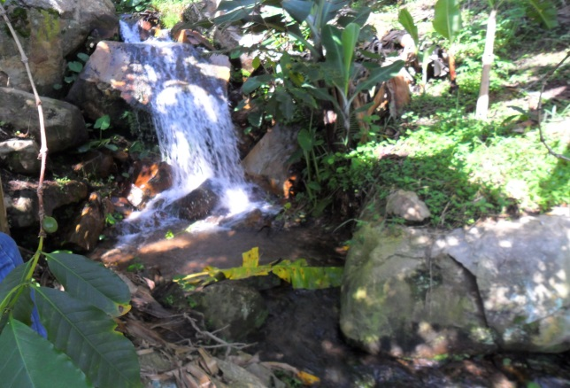

Mukazi Anyara Gravity Flow Scheme located in Rukiri Sub County. It is surrounded by natural forest species, has waterfalls and mixed farming of different crop enterprises such as coffee, bananas, vegetables being practiced in the neighborhood. The site is potential for agro-tourism and recreation

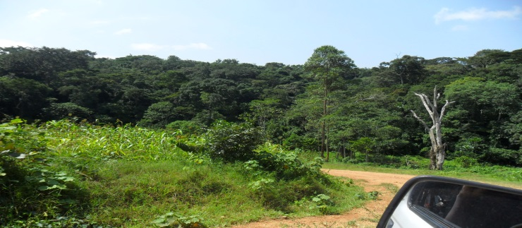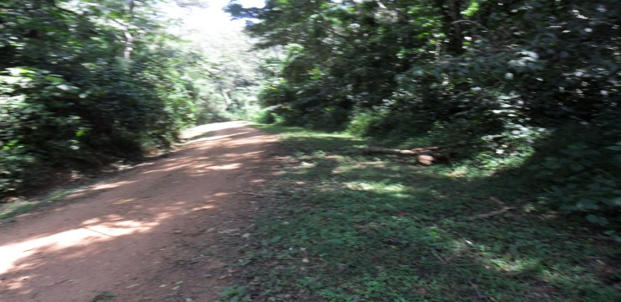
Kasyoha Kitomi Forest Reserve in Kicuzi Sub-County, it harbors special tree species, medicinal, special insects like butterflies, different beautiful birds for tourism

CONTACTS
- Mr. Kazwengye Melichiadis-District Chairperson
- Mr. Mpirirwe Justus the District Planner Email:joanayebare@gmail.com
- Mr. Tom Rukundo-District Commercial Officer Tel. 0757161705 Email:tomrukundo@yahoo.com
- Mr. Zephline Tumwesigye, the District Production and Marketing Officer

