“THANK YOU FOR FIGHTING CORRUPTION” IGG TELLS IBANDA
By Byaruhanga Sylas
The Deputy Inspector General of Government Ms Mariam Mutonyi has commended the efforts by the Ibanda District Local Government in fighting against corruption in the district.
According to the report read to the district stakeholders by Ms Mutonyi, Ibanda district did not have any serious corruption case to address.
“We are in this district to say thank you for the work done and to encourage you to continue with the spirit of fighting against corruption scourge” Mutonyi said.
The IGG also thanked Ibanda district for maintaining its position among the best five districts in the local government assessment for the last four years.
She congratulated Ibanda for attaining the district status since it was her first time in the district.
During the same sitting, Mr Ahimbisibwe Nathan the District Chief Administrative Officer said that corruption levels have remained low in Ibanda due to the fact that citizens are relatively reach.
Ahimbisibwe informed the inspectorate that a casual laborer in Ibanda earns between 7000= to 10,000= which is above poverty line thus leaving the people of Ibanda self-sustaining and therefore no cause for corruption.
In her response, the deputy RDC Ibanda called for the increased budget for the district since government money was being put to proper use.
The team proceeded to Nyabuhikye prison where they interacted with prison officials.
In prison, officials informed the IGG that food harvested is being put to the right use and that the money corrected had proper accountability after deducting the percentage paid to prisoners.
Prison Officials informed the IGG that a prisoner earns only 500= per day worked.

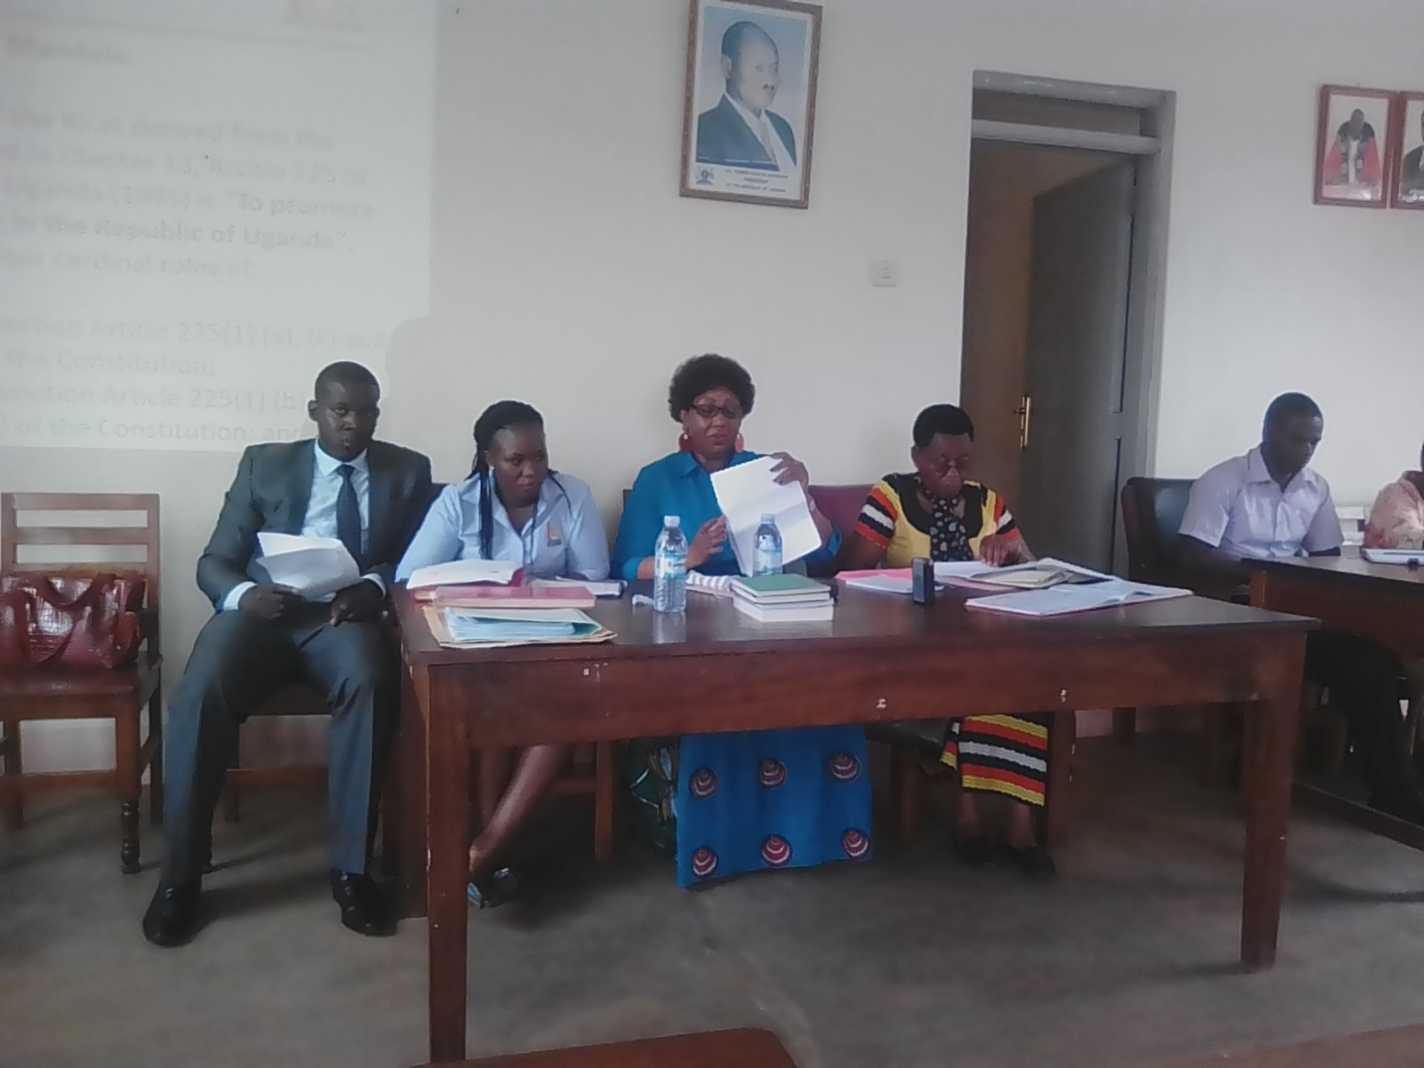
Ms Mutonyi (in blue dress) reading the report to the District stakeholders in the council hall. Photo by Sylas Byaruhanga

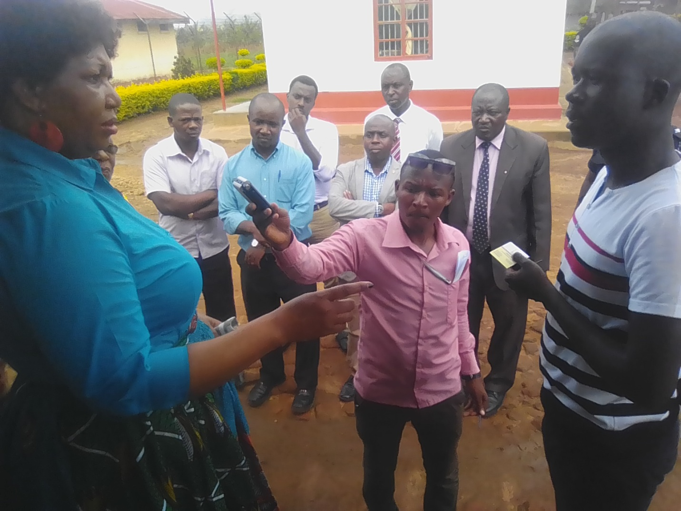
Ms Mutonyi flanked by IG team interacting with Nyabuhikye prison officials. Photo by Sylas Byaruhanga

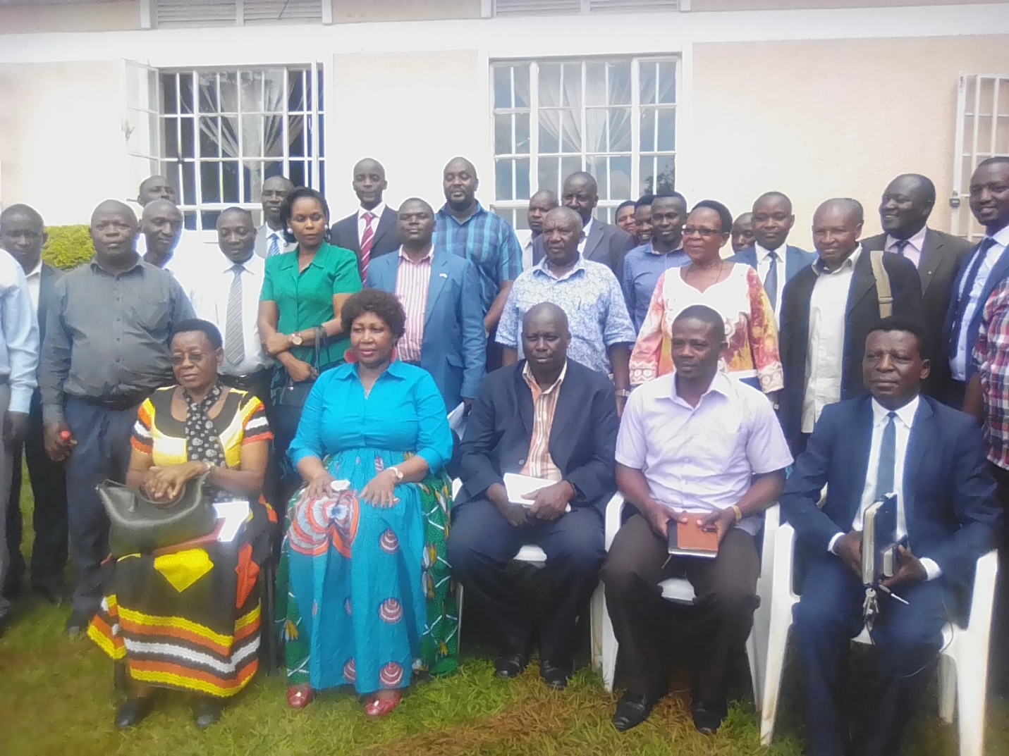
The IG team poses for a photo with the District Stakeholders after the meeting. Photo by Sylas Byaruhanga

