IBANDA CELEBRATES WOMEN’S AND WATER DAY AMID CALLS FOR NRM SUPPORT
BY SYLAS BYARUHANGA
On 22nd March 2019, Ibanda District held double celebrations for women’s day and world water day. Celebrations took place at Kigunga P/S play ground in Rukiri Sub County in Ibanda District.
State Minister for Environment Mary Gorreti Kitutu, Woman Mp Jovline Kalisa, Ibanda County North legislator David Gumisiriza and Chairman LCV Kajwenge Melchiadis blessed the celebrations.
Prior to the day, there was sanitation week where a number of activities including Ibanda town cleaning and sanitation competitions were held where Schools, Health Centers and individuals participated.
Those who emerged the winners were awarded gifts at the function which included jerry cans, bars of soap and mathematical sets and books for school children.
Other gifts included hard cash from the minister and the area woman member of parliament.
While at the function, the Ibanda Woman MP praised president Museveni for laying strategies for uplifting the status of women noting that a woman is no longer someone who was thought to be reserved for only home chores.
Speaking as the chief guest, minister Kitutu thanked the people of Ibanda for electing a hardworking and developmental woman.
She also called on the people to continue supporting NRM noting that it is the only party with vision of developing Uganda and Ibanda in particular
Earlier before Major Guma had cautioned the youth of Ibanda to desist from falling victims of harmful propaganda of Hon. Bobi Wine’s people power.
At the same function, the minister launched the construction work of gravity water which is being worked on by the living water international at Kigunga P/S.

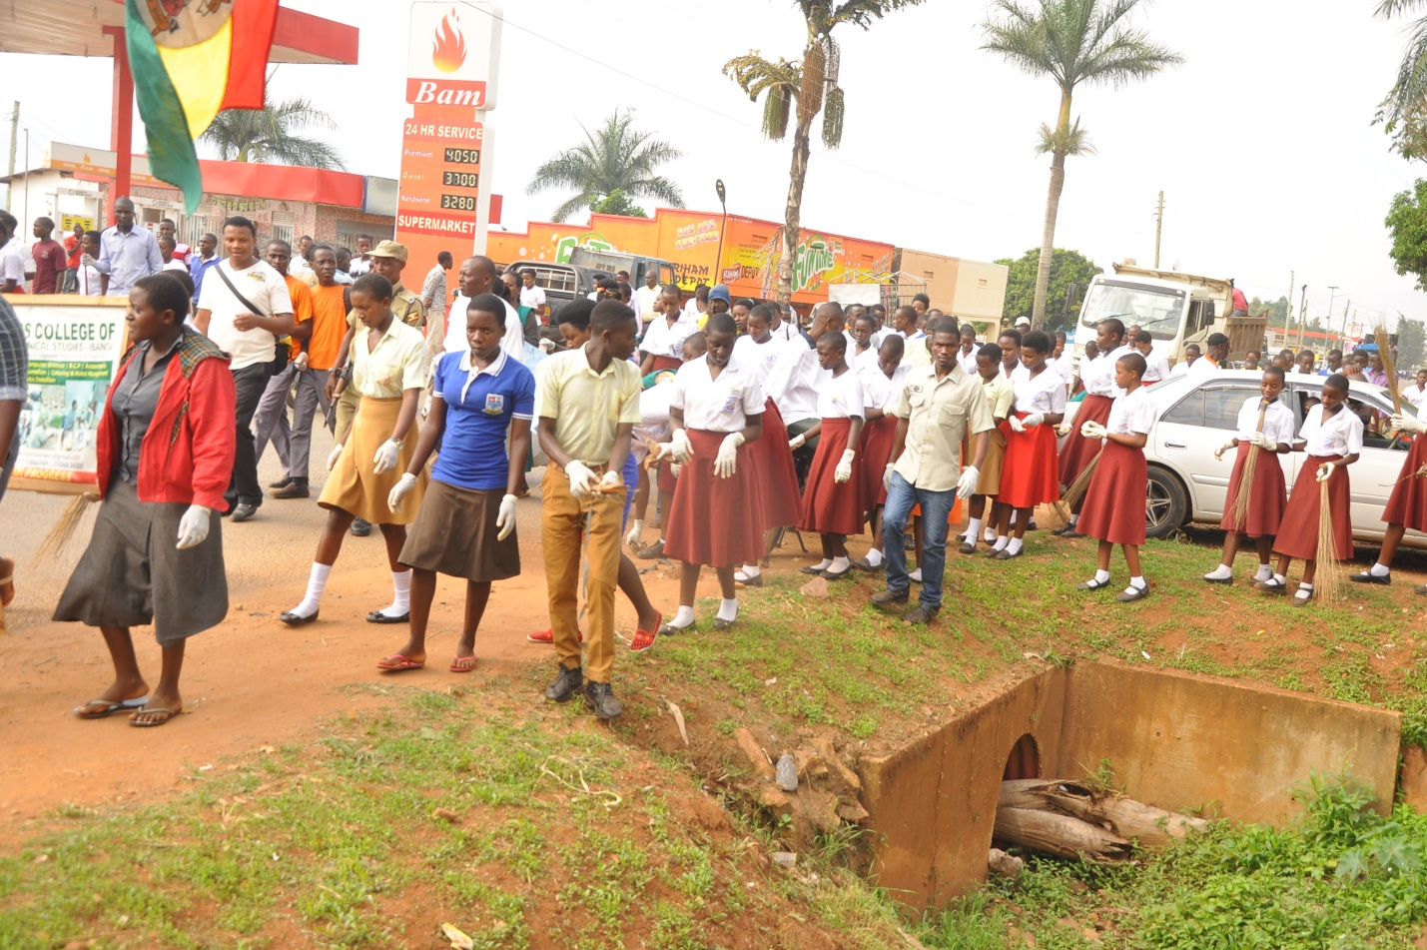STUDENTS OF KIBUBURA GIRLS, ALLIANCE SS, IMPERIAL SS PARTICIPATE IN IBANDA TOWN CLEANING TO COMEMORATE WORLD WOMEN'S DAY. Photo by Sylas Byaruhanga

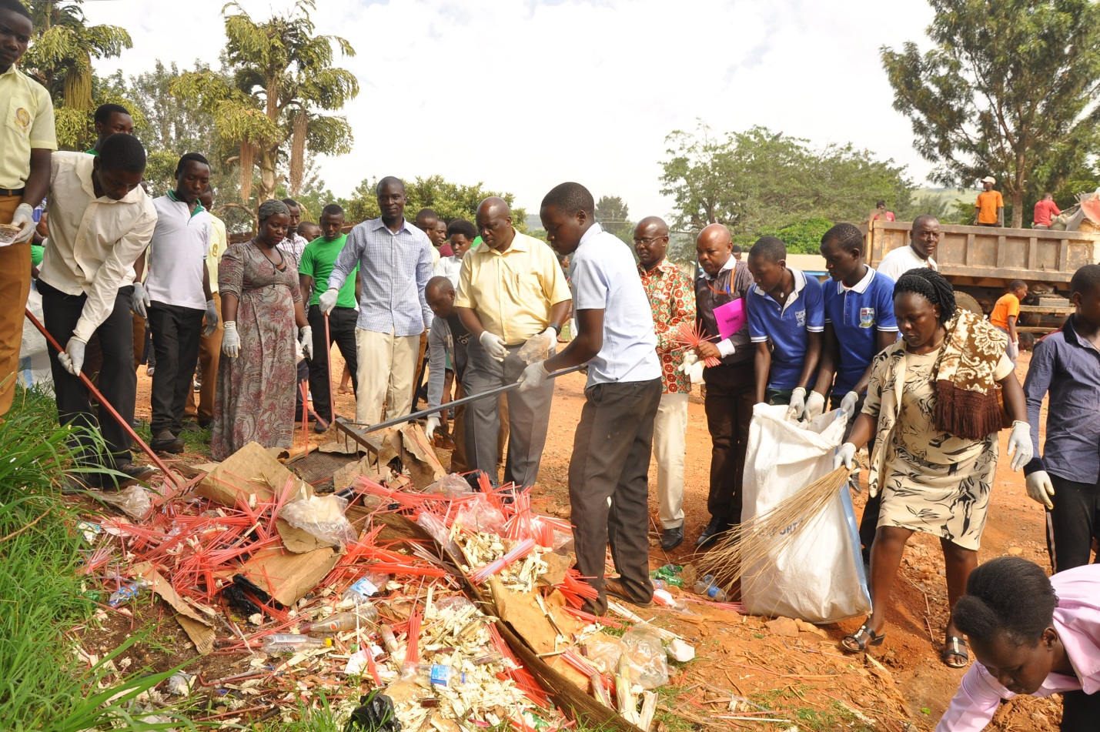
Ibanda Town Mayor Kibeherere flanked by other municipal and district staff participate in sanitation week. Photo by Sylas Byaruhanga

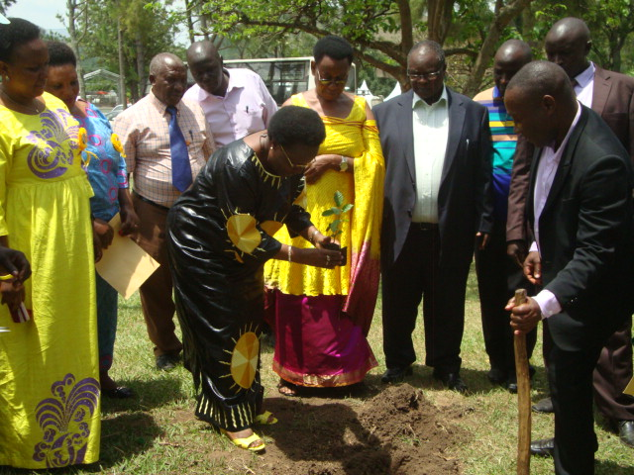
Minister Kitutu, MP kaliisa, Deputy RDC and Chair Kajwengye plant a tree at Kigunga PS to mark world women's day celebrations.

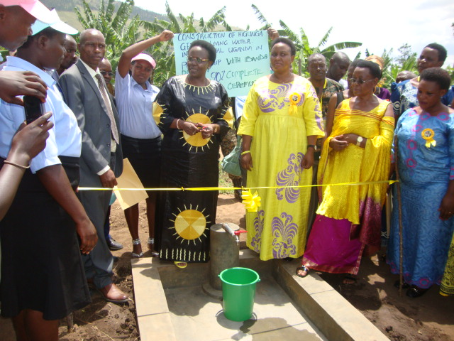
Figure 1Minister Kitutu commissioning the construction of water project at Kigung a PS. The project is being worked on by Living Water international. The minister ordered the environment officer of the district to ensure more trees are planted to preserve such water. Photo by Sylas Byaruhanga.

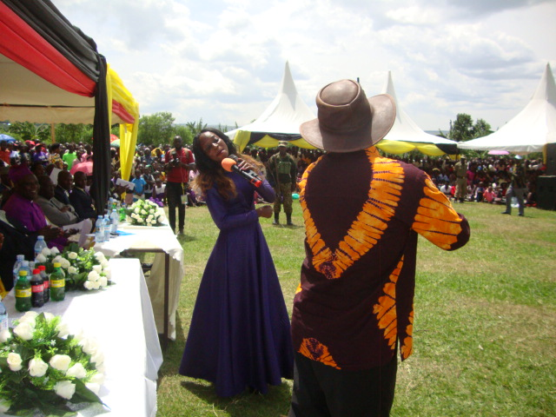
Singer Carlo Kyambala performed at the function.
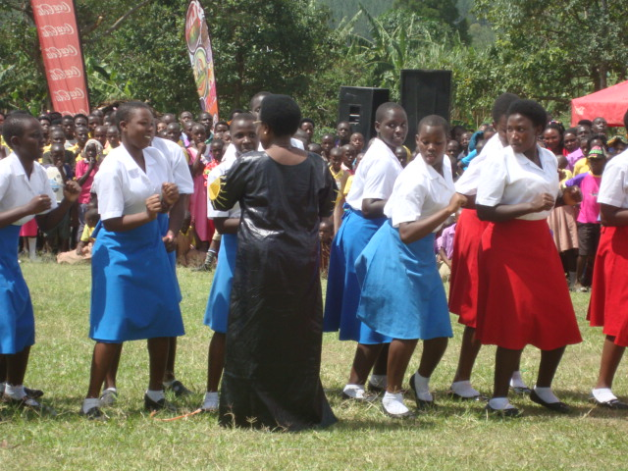
Students of Kibubura Girls SS entertaining the minister at the function.

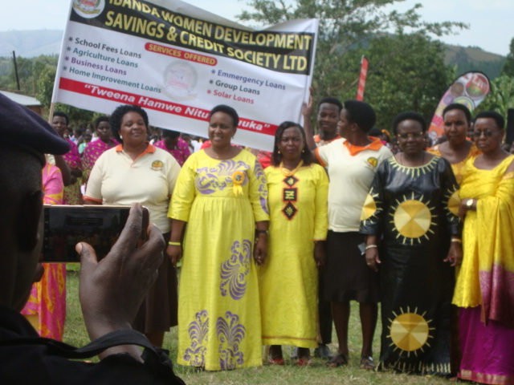
Members of Ibanda Women Deveoplment SAACO posing for a photo with Kitutu and Kaliisa. Kitutu handed over a 5M Cash contribution towards development of the SAACO. Photo by Sylas Byaruhanga

